**Step 1: Downloading Android Studio for Windows**

Download android studio from official website

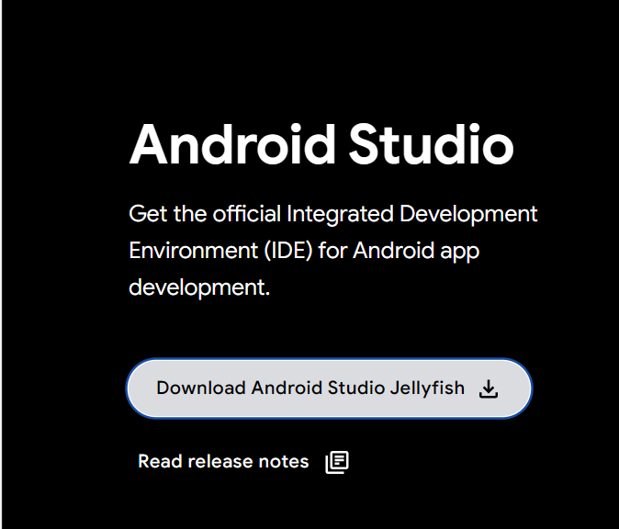

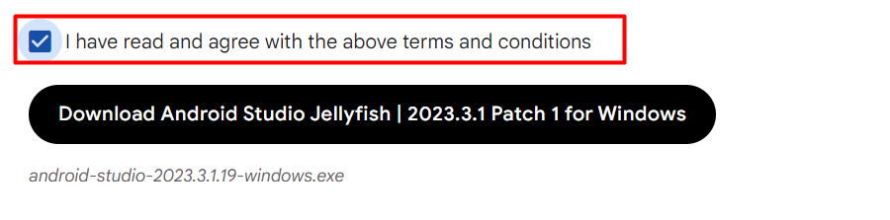

**Step 2: Start the Installer**

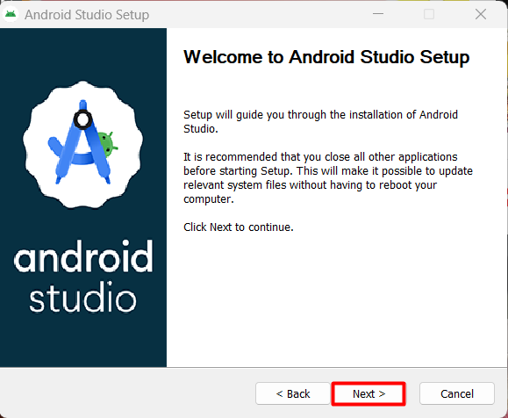

**Step 2: Choose Components**

The first step in the installation wizard is to Choose Components. By default, the only component selected is the Android Virtual Device, which is required for running and testing your Android apps on an emulator:

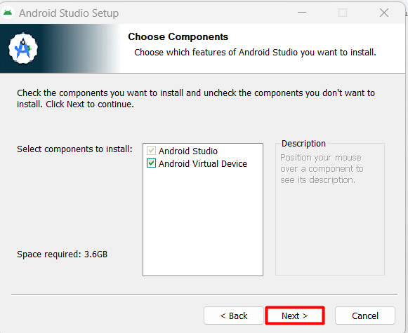

**Step 3: Choose the Installation Location and click next**

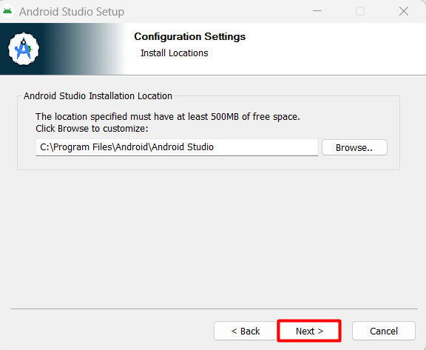

**Step 4: Choose the Start Menu Folder and Install**

**Click install**

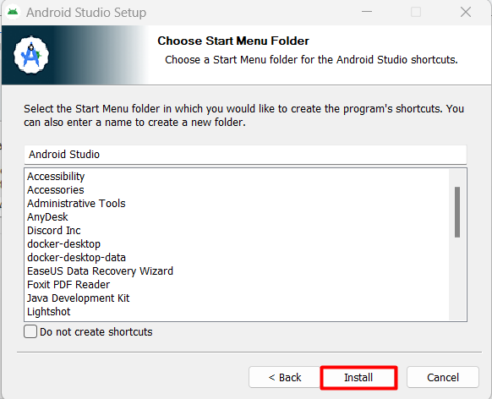

**Step 5: Complete the Installation**

**Click Finish**

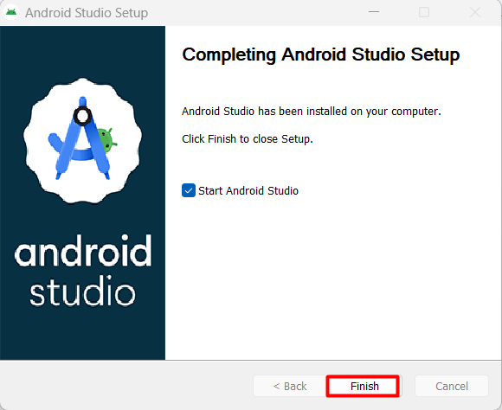

**Step 6: Import Android Studio Settings**

Select Do not import settings

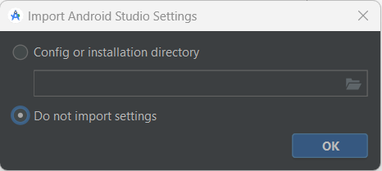

**Step 7: Choose Settings**

**Select standard and click on next**

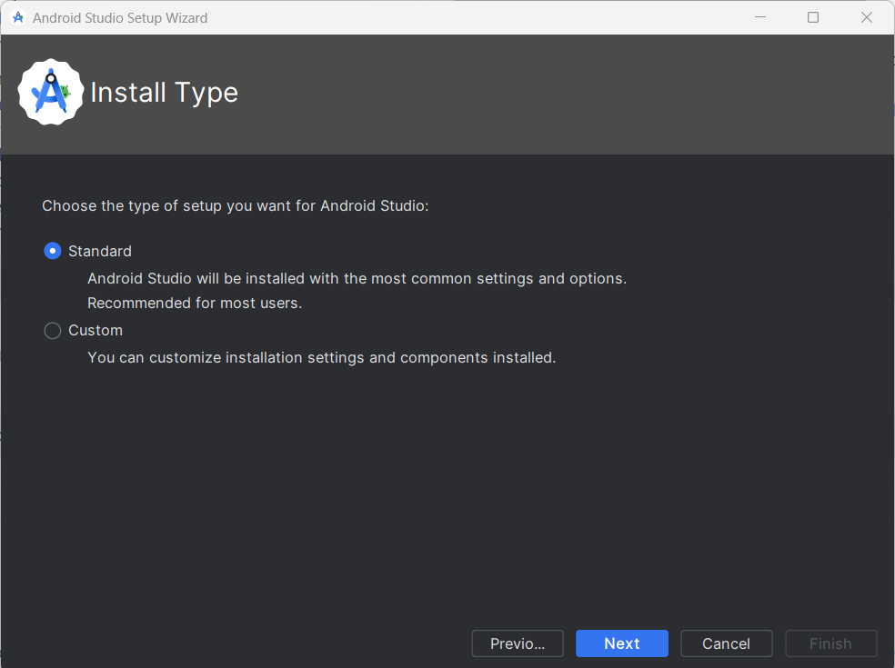

**Step 8: Accept License Agreement**

At the bottom of the screen, you’ll see a Finish button which will only be enabled if you accept the license agreement. Once you click Finish, the installation process will be complete, and Android Studio will be ready for use.

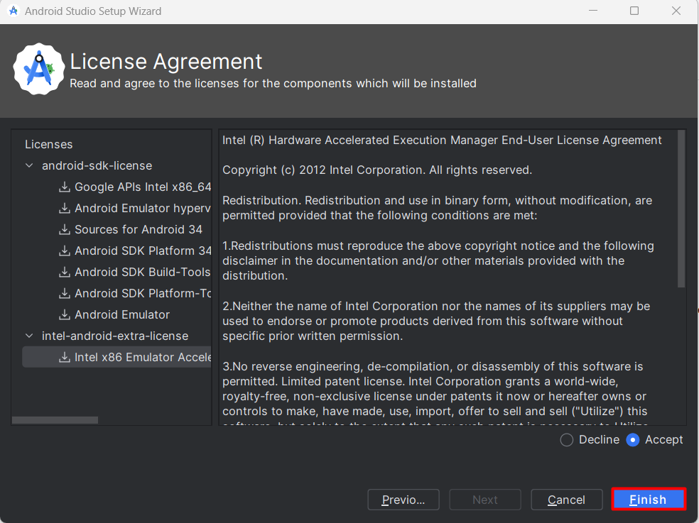

# Main Activity.java

*package* com.example.hellouniverse;  
  
*import* android.os.Bundle;  
  
*import* androidx.activity.EdgeToEdge;  
*import* androidx.appcompat.app.AppCompatActivity;  
*import* androidx.core.graphics.Insets;  
*import* androidx.core.view.ViewCompat;  
*import* androidx.core.view.WindowInsetsCompat;  
  
*public class* MainActivity *extends* AppCompatActivity {  
  
 @Override  
 *protected void* onCreate(Bundle savedInstanceState) {  
 *super*.onCreate(savedInstanceState);  
 EdgeToEdge.*enable*(*this*);  
 setContentView(R.layout.*activity_main*);  
 ViewCompat.*setOnApplyWindowInsetsListener*(findViewById(R.id.*main*), (v, insets) -> {  
 Insets systemBars = insets.getInsets(WindowInsetsCompat.Type.*systemBars*());  
 v.setPadding(systemBars.left, systemBars.top, systemBars.right, systemBars.bottom);  
 *return* insets;  
 });  
 }  
}

# Mainactivity.xml

*package* com.example.hellouniverse;  
  
*import* android.os.Bundle;  
  
*import* androidx.activity.EdgeToEdge;  
*import* androidx.appcompat.app.AppCompatActivity;  
*import* androidx.core.graphics.Insets;  
*import* androidx.core.view.ViewCompat;  
*import* androidx.core.view.WindowInsetsCompat;  
  
*public class* MainActivity *extends* AppCompatActivity {  
  
 @Override  
 *protected void* onCreate(Bundle savedInstanceState) {  
 *super*.onCreate(savedInstanceState);  
 EdgeToEdge.*enable*(*this*);  
 setContentView(R.layout.*activity_main*);  
 ViewCompat.*setOnApplyWindowInsetsListener*(findViewById(R.id.*main*), (v, insets) -> {  
 Insets systemBars = insets.getInsets(WindowInsetsCompat.Type.*systemBars*());  
 v.setPadding(systemBars.left, systemBars.top, systemBars.right, systemBars.bottom);  
 *return* insets;  
 });  
 }  
}

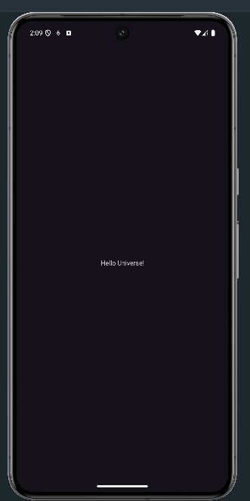

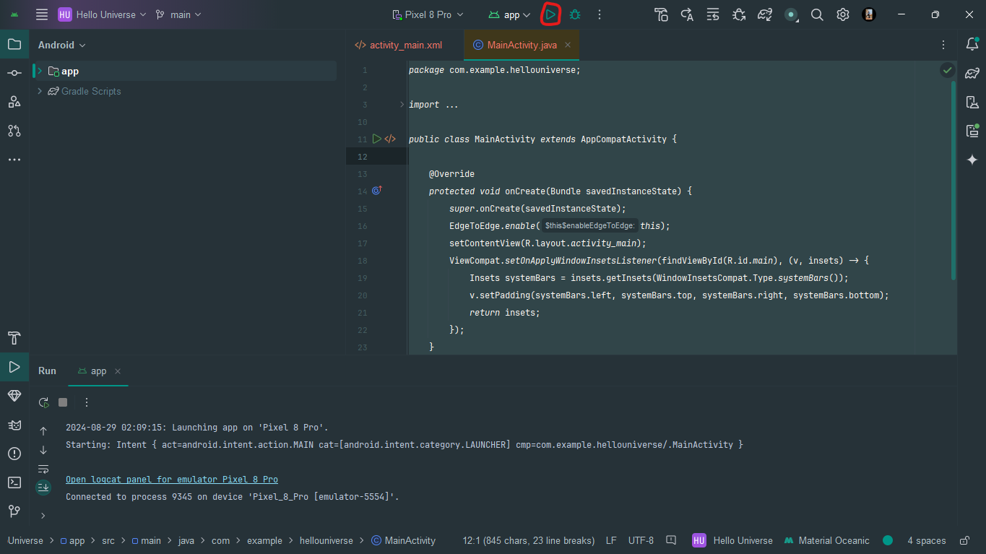

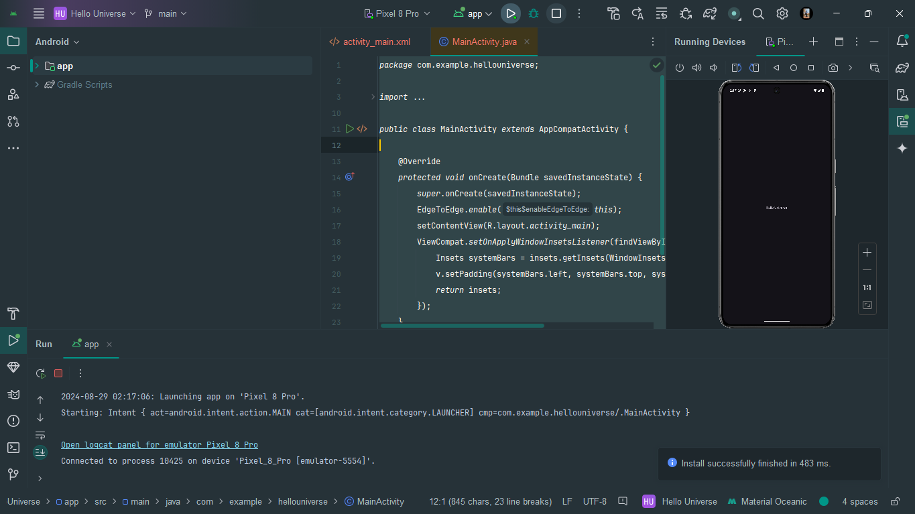

# Main Activity.java

package com.example.loginreset;

import androidx.appcompat.app.AppCompatActivity;

import android.os.Bundle;

import android.view.View;

import android.widget.Button;

import android.widget.EditText;

import android.widget.TextView;

import com.example.loginreset.R;

public class MainActivity extends AppCompatActivity {

Button Submit,Reset;

EditText Email,Password;

TextView Result;

@Override

protected void onCreate(Bundle savedInstanceState) {

super.onCreate(savedInstanceState);

setContentView(R.layout.activity_main);

Submit=findViewById(R.id.Login);

Reset=findViewById(R.id.Reset);

Email=findViewById(R.id.Email);

Password=findViewById(R.id.Password);

Result=findViewById(R.id.Result);

Submit.setOnClickListener(new View.OnClickListener() {

@Override

public void onClick(View v) {

String email=Email.getText().toString();

String password=Password.getText().toString();

Result.setText("Email Id:"+email+"\nPassword: "+password);

}

});

Reset.setOnClickListener(new View.OnClickListener() {

@Override

public void onClick(View v) {

Email.setText("");

Password.setText("");

Result.setText("");

}

});

}

}

# Main Activity.xml

<?*xml version*="1.0" *encoding*="utf-8"?>  
<androidx.constraintlayout.widget.ConstraintLayout *xmlns:android*="http://schemas.android.com/apk/res/android"  
 *xmlns:app*="http://schemas.android.com/apk/res-auto"  
 *xmlns:tools*="http://schemas.android.com/tools"  
 *android:layout_width*="match_parent"  
 *android:layout_height*="match_parent"  
 *tools:context*=".MainActivity">  
  
 <Button  
 *android:id*="@+id/Reset"  
 *android:layout_width*="126dp"  
 *android:layout_height*="54dp"  
 *android:text*="Reset"  
 *android:textSize*="24sp"  
 *app:layout_constraintBottom_toBottomOf*="parent"  
 *app:layout_constraintEnd_toEndOf*="parent"  
 *app:layout_constraintHorizontal_bias*="0.852"  
 *app:layout_constraintStart_toStartOf*="parent"  
 *app:layout_constraintTop_toTopOf*="parent"  
 *app:layout_constraintVertical_bias*="0.475" />  
  
 <TextView  
 *android:id*="@+id/textView"  
 *android:layout_width*="278dp"  
 *android:layout_height*="89dp"  
 *android:text*="LOGIN ACTIVITY"  
 *android:textColor*="#ff0000"  
 *android:textSize*="34sp"  
 *android:textStyle*="bold"  
 *app:layout_constraintBottom_toBottomOf*="parent"  
 *app:layout_constraintEnd_toEndOf*="parent"  
 *app:layout_constraintHorizontal_bias*="0.496"  
 *app:layout_constraintStart_toStartOf*="parent"  
 *app:layout_constraintTop_toTopOf*="parent"  
 *app:layout_constraintVertical_bias*="0.096" />  
  
 <EditText  
 *android:id*="@+id/Email"  
 *android:layout_width*="wrap_content"  
 *android:layout_height*="wrap_content"  
 *android:ems*="10"  
 *android:inputType*="textEmailAddress"  
 *android:hint*=" Enter your Email"  
 *app:layout_constraintBottom_toBottomOf*="parent"  
 *app:layout_constraintEnd_toEndOf*="parent"  
 *app:layout_constraintHorizontal_bias*="0.666"  
 *app:layout_constraintStart_toStartOf*="parent"  
 *app:layout_constraintTop_toTopOf*="parent"  
 *app:layout_constraintVertical_bias*="0.263" />  
  
 <TextView  
 *android:id*="@+id/textView2"  
 *android:layout_width*="89dp"  
 *android:layout_height*="48dp"  
 *android:shadowColor*="#00F6F6F6"  
 *android:text*="EMAIL: "  
 *android:textColor*="#FF5722"  
 *android:textSize*="18sp"  
 *android:textStyle*="bold"  
 *app:layout_constraintBottom_toBottomOf*="parent"  
 *app:layout_constraintEnd_toEndOf*="parent"  
 *app:layout_constraintHorizontal_bias*="0.067"  
 *app:layout_constraintStart_toStartOf*="parent"  
 *app:layout_constraintTop_toTopOf*="parent"  
 *app:layout_constraintVertical_bias*="0.274" />  
  
 <TextView  
 *android:id*="@+id/textView3"  
 *android:layout_width*="92dp"  
 *android:layout_height*="46dp"  
 *android:shadowColor*="#00F6F6F6"  
 *android:text*="Password: "  
  
 *android:textColor*="#FF5722"  
 *android:textSize*="18sp"  
 *android:textStyle*="bold"  
 *app:layout_constraintBottom_toBottomOf*="parent"  
 *app:layout_constraintEnd_toEndOf*="parent"  
 *app:layout_constraintHorizontal_bias*="0.072"  
 *app:layout_constraintStart_toStartOf*="parent"  
 *app:layout_constraintTop_toTopOf*="parent"  
 *app:layout_constraintVertical_bias*="0.356" />  
  
 <EditText  
 *android:id*="@+id/Password"  
 *android:layout_width*="wrap_content"  
 *android:layout_height*="wrap_content"  
 *android:ems*="10"  
 *android:hint*="Enter Your Password"  
 *android:inputType*="textPassword"  
 *app:layout_constraintBottom_toBottomOf*="parent"  
 *app:layout_constraintEnd_toEndOf*="parent"  
 *app:layout_constraintHorizontal_bias*="0.666"  
 *app:layout_constraintStart_toStartOf*="parent"  
 *app:layout_constraintTop_toTopOf*="parent"  
 *app:layout_constraintVertical_bias*="0.357" />  
  
 <Button  
 *android:id*="@+id/Login"  
 *android:layout_width*="126dp"  
 *android:layout_height*="54dp"  
 *android:text*="Login"  
 *android:textSize*="24sp"  
 *app:layout_constraintBottom_toBottomOf*="parent"  
 *app:layout_constraintEnd_toEndOf*="parent"  
 *app:layout_constraintHorizontal_bias*="0.1"  
 *app:layout_constraintStart_toStartOf*="parent"  
 *app:layout_constraintTop_toTopOf*="parent"  
 *app:layout_constraintVertical_bias*="0.476" />  
  
 <TextView  
 *android:id*="@+id/Result"  
 *android:layout_width*="170dp"  
 *android:layout_height*="78dp"  
 *android:text*="TextView"  
 *app:layout_constraintBottom_toBottomOf*="parent"  
 *app:layout_constraintEnd_toEndOf*="parent"  
 *app:layout_constraintHorizontal_bias*="0.24"  
 *app:layout_constraintStart_toStartOf*="parent"  
 *app:layout_constraintTop_toTopOf*="parent"  
 *app:layout_constraintVertical_bias*="0.719" />  
</androidx.constraintlayout.widget.ConstraintLayout>

**OUTPUT:**

